Industrial Visit Report

Course code: CIT-222
Course Title: Information System Analysis & Design Sessional
Name of the Industry: Kohinoor Auto Rice Limited
Submitted To
Golam Md. Muradul Bashir.
Professor,
Department of Computer and Communication Engineering.

Md Atikur Rahman
Professor,
Department of Computer Science and Information Technology

Submitted By
Name: Md. Afridi Alom Pranto
ID No: 2102027
Reg No: 10154
Session: 2021-22

Name: Mehedi Hasan
ID No: 2102007
Reg No: 10134
Session: 2021-22
Level-II, Semester-II

Name: Nazmus Sakib
ID No: 2102066
Reg No: 10193
Session: 2021-22
Level-II, Semester-II

PATUAKHALI SCIENCE AND TECHNOLOGY UNIVERSITY.
Dumki, Patuakhali-8602.
Industry Type: Auto Rice Mill
Visited Industry Name: Kohinoor Auto Rice Limited
Location:
House: Purbo Sharikkhali, Bashak Bazar,
Upazila: Patuakhali Sadar,
District: Patuakhali,
Division: Barisal.
Number of Total Workers: 45
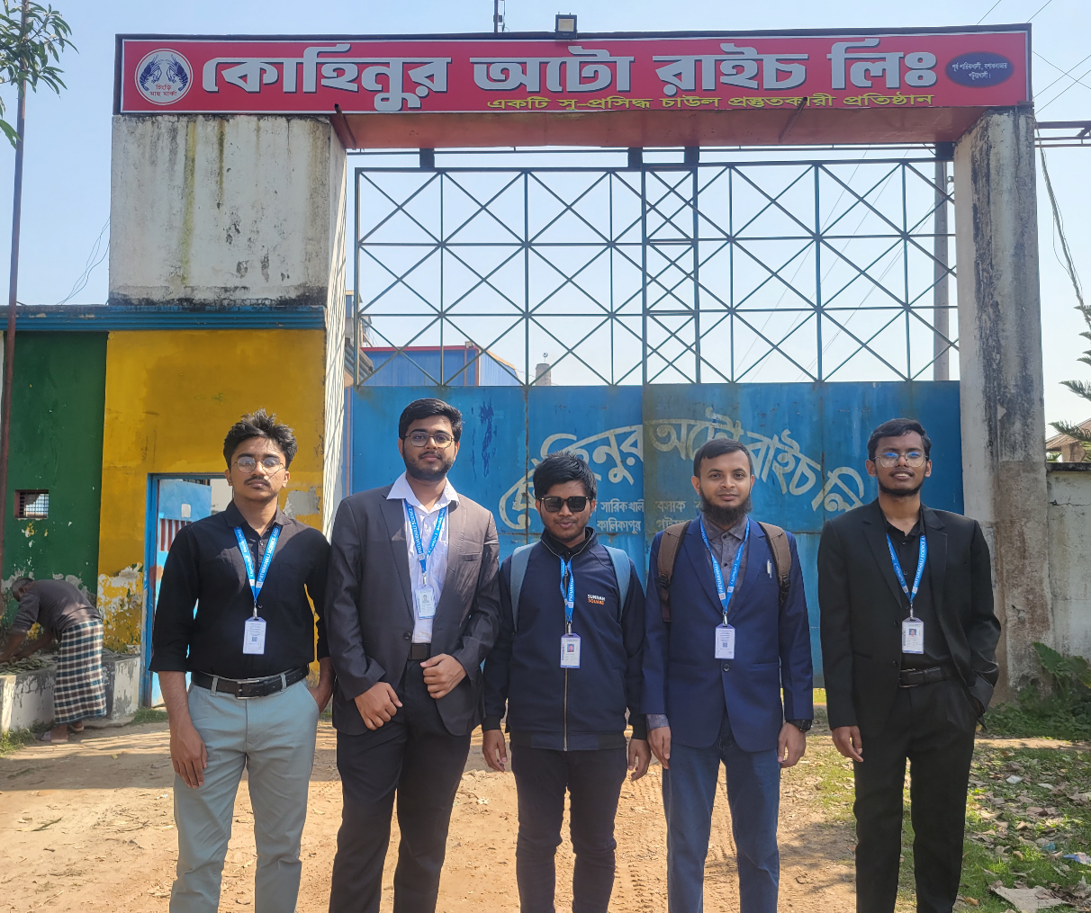
1. Introduction
During our course on System Analysis, we had the opportunity to visit Kohinoor Auto Rice Limited, a modern rice processing facility. The visit aimed to understand their operational workflow and identify potential inefficiencies or areas for digital automation. Following the visit, our team decided to focus on one of the key operational challenges faced by the facility: inventory and operational management.
2. Working Process of Kohinoor Auto Rice Limited
Auto rice milling is a term that signifies the whole action of rice processing from cultivating to yielding the final eatable product. A plant/industrial setup which is capable of pulling off this huge task is known as an Auto Rice Milling Plant.
- Parboiling Section
The parboiling section is responsible for the conditioning of rice crops by partially cooking and drying it beforehand. The parboiling of rice crops makes it hard enough to withstand the process of rice milling. Parboiling is also responsible for getting rid of the hull that comes along with the crop.
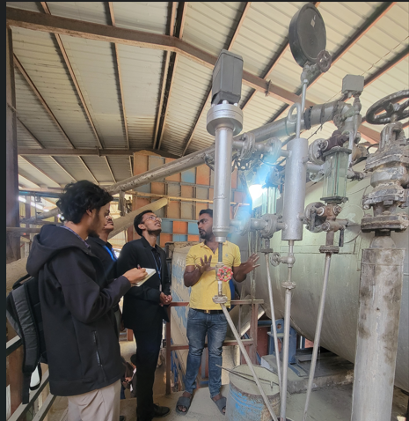

Figure: Parboiling Section

B) Drying Section
The drying section of an Auto Rice Milling Plant is responsible for drying the parboiled rice crop and minimizing the moisture content in the rice. Drying of seeds is crucial since it ensures the durability of the rice and its good quality.
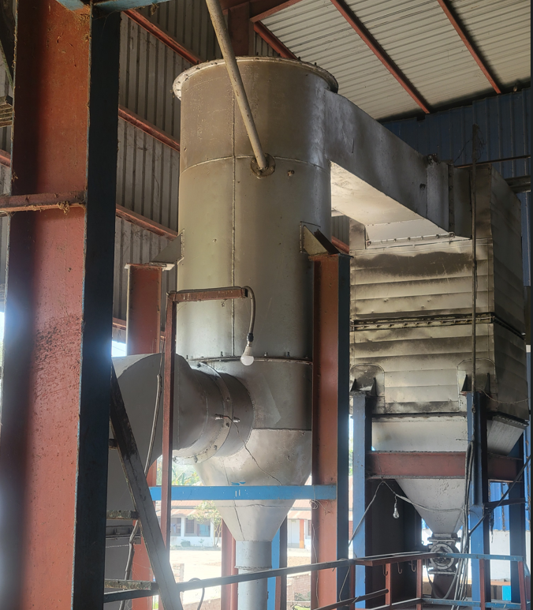
Figure: Drying Section

C) Milling Section
Rice Milling is one of the most important parts of Rice Processing. The basic objective of rice milling is to remove the unwanted part/ non-eatable part of the rice. The husk and the bran layers are removed in this stage of rice processing.

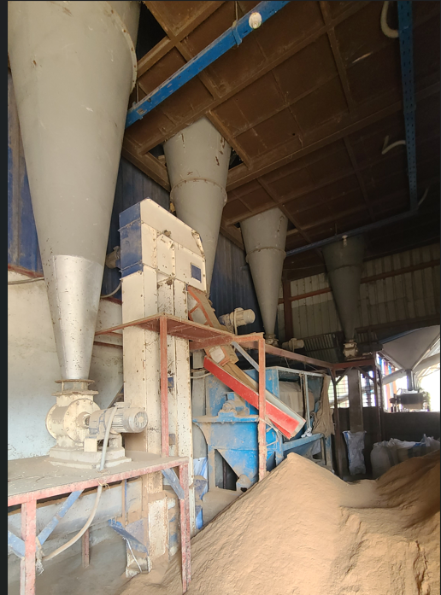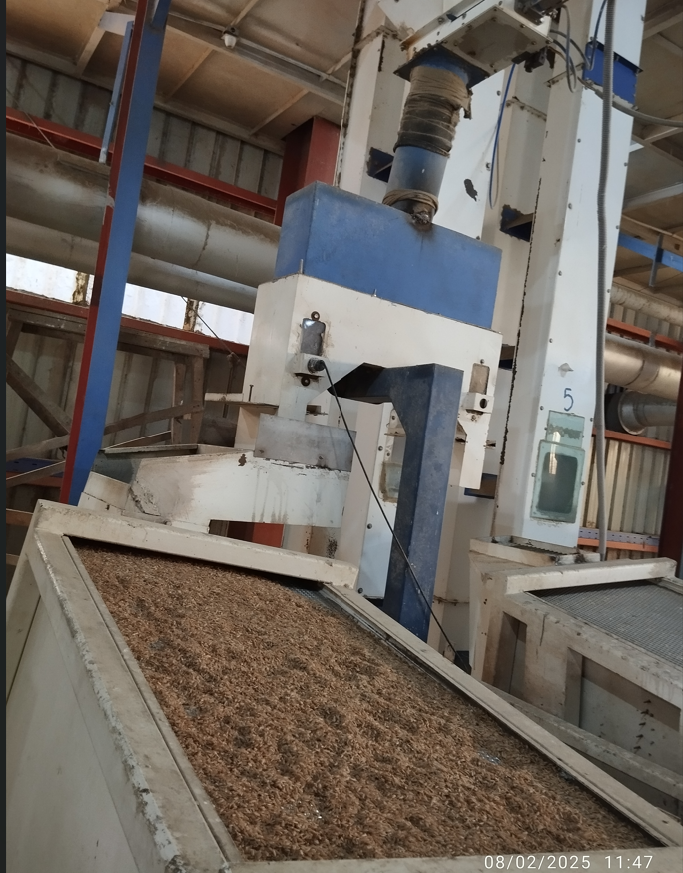
Figure: Milling Section

D) Bagging Section
Once we get over with Rice Milling, we have pure consumable rice left with us. This rice needs to be packed in order to make it last longer and facilitate the transportation of rice from one place to another.
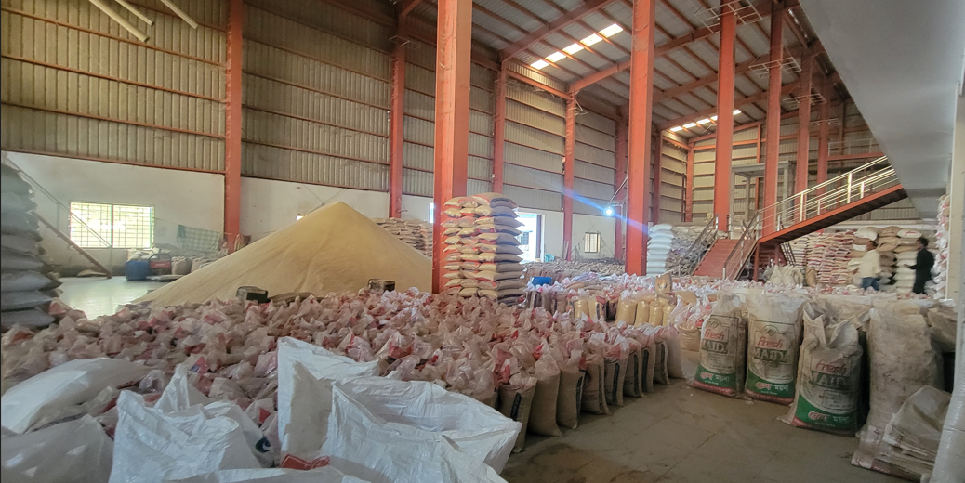
Figure: Bagging Section

3. Problem Identification
Through interviews with staff and observation of current workflows, we identified the following key problems:
- Manual Record Keeping: Inventory records are maintained on paper or in basic spreadsheets, leading to errors, duplication, and data loss.
- Lack of Real-time Inventory Updates: There is no system to update inventory in real-time as rice is processed, packaged, or shipped.
- Poor Traceability: Tracking of raw materials, processing batches, and final products is difficult due to disjointed records.
- Inefficient Reporting: Generating reports for stock, production, and sales takes considerable time and often lacks accuracy.
- No Centralized System: Data is siloed across departments without centralized access or integration.

4.Feasibility Analysis
- A report from 2021 mentions over 18,700 rice mills in total (including public and private).
- The total business market for Auto Rice Mills in Bangladesh is estimated at ৳500 billion per year.

5. Project Objective
The primary objective of this project is to develop an Automated System for Rice Inventory and Operations that will:
- Digitize and centralize inventory data.
- Enable real-time tracking of stock and operations.
- Generate accurate and timely reports.
- Improve overall efficiency, traceability, and accountability.

6. System Overview
6.1 Target Users
- Inventory Managers
- Production Supervisors
- Sales and Dispatch Officers
- Administrative Staff
6.2 Development Platform
- Programming Language: C#
- Framework: .NET
- Database: SQL-SERVER

7. Business Policy:
>Our software is absolutely free!
How we generate Revenue:
✅ Charge per Ton: 100 Tk
✅ Monthly Processed Quantity: 35 – 45 tons
✅ Average Processed Quantity: 40 tons
📅 Monthly Earnings:
40 tons × 100 Tk = 4,000 Tk
📈 Yearly Earnings:
4,000 Tk × 12 = 48,000 Tk
*This is the earning summary from only one Auto-Rice Mill

8. Features of Our Software
User Authentication
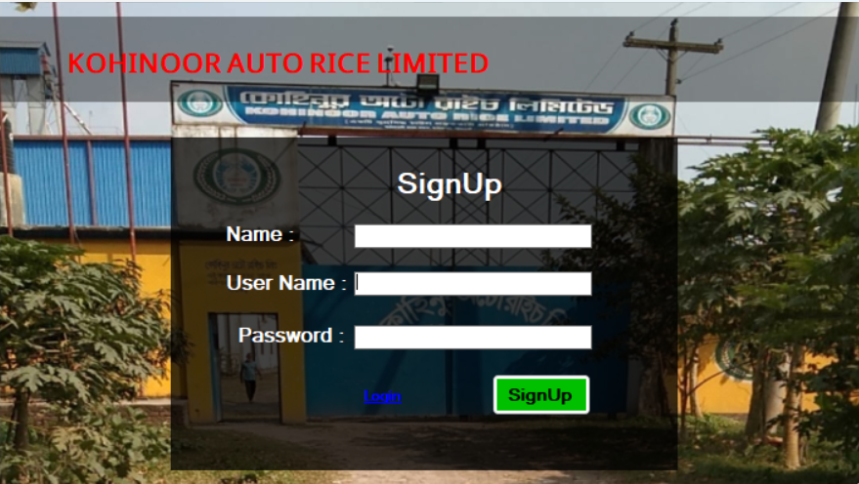
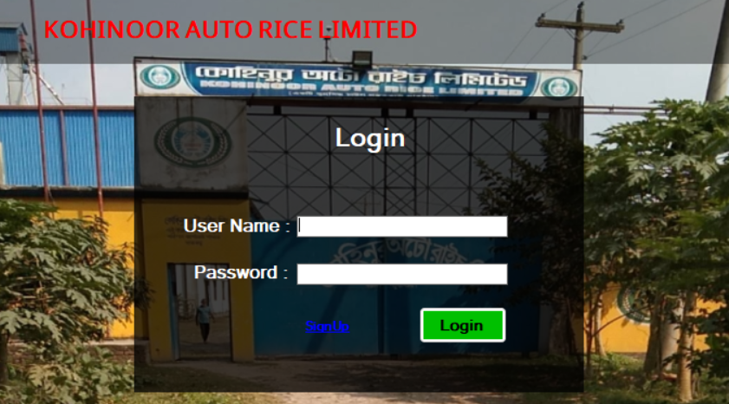

Admin Panel
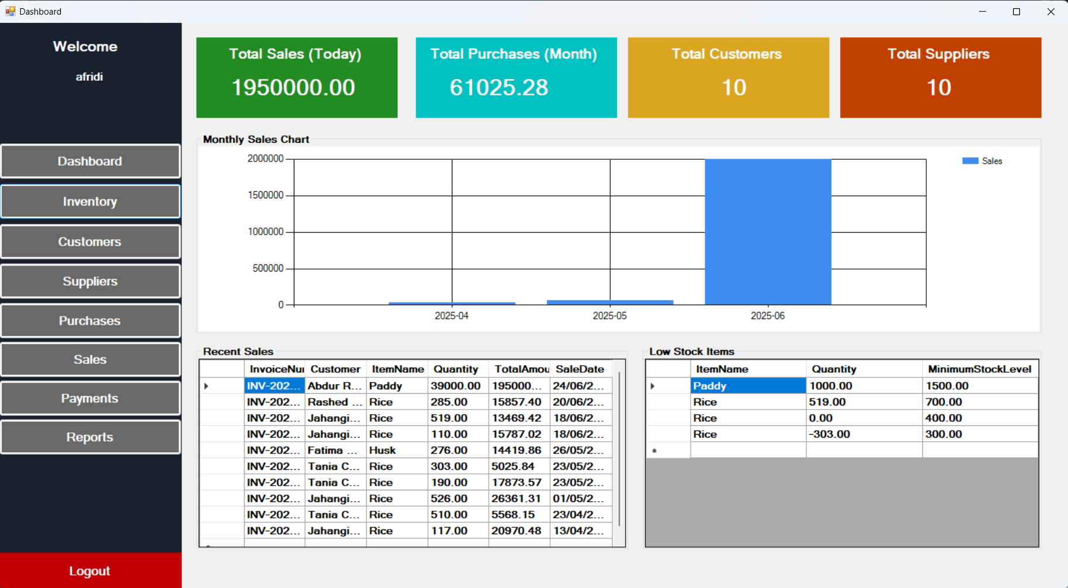

Inventory Management
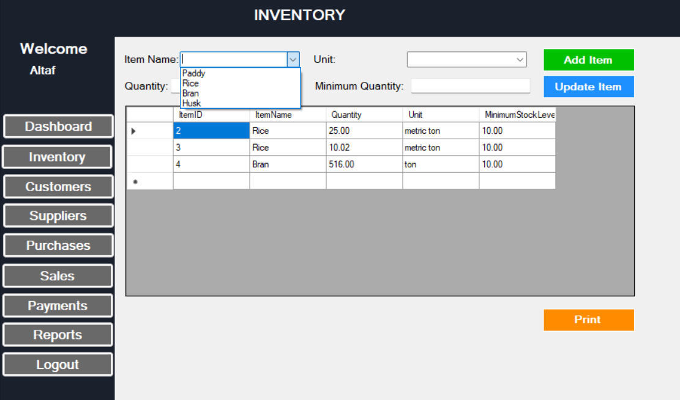
Customers Management
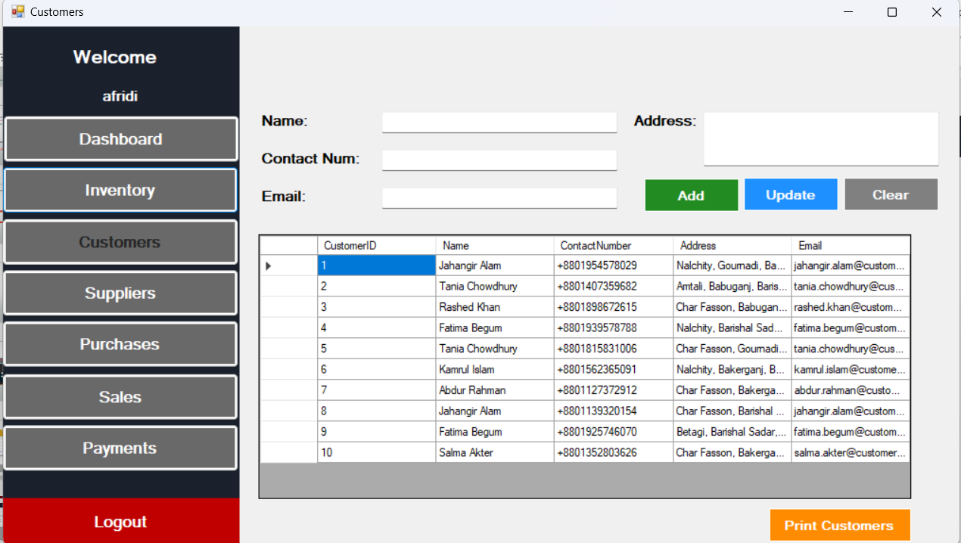
Suppliers Management
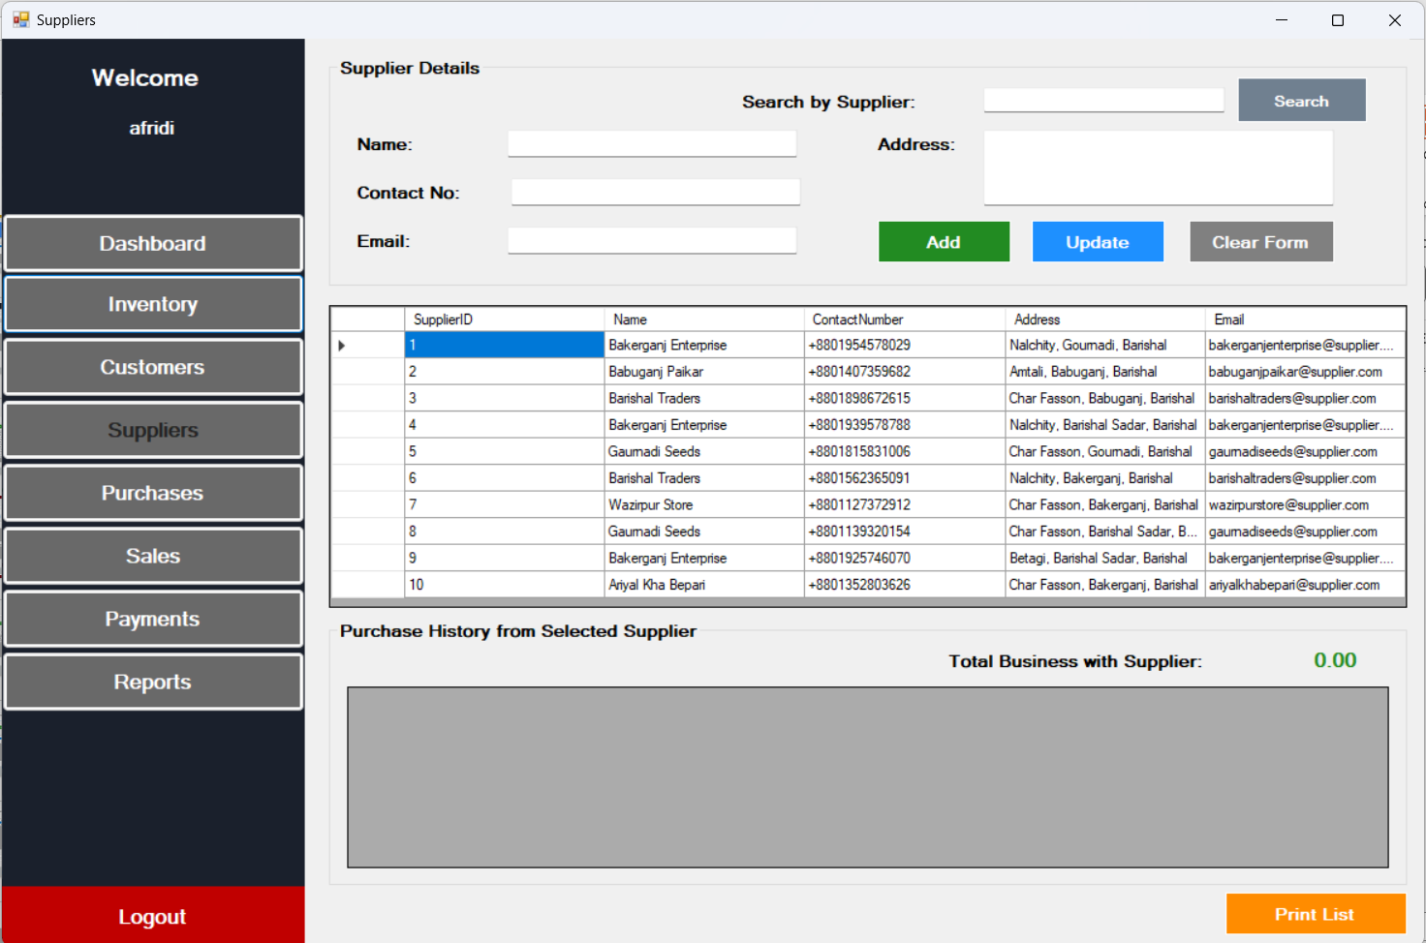
Purchases Section
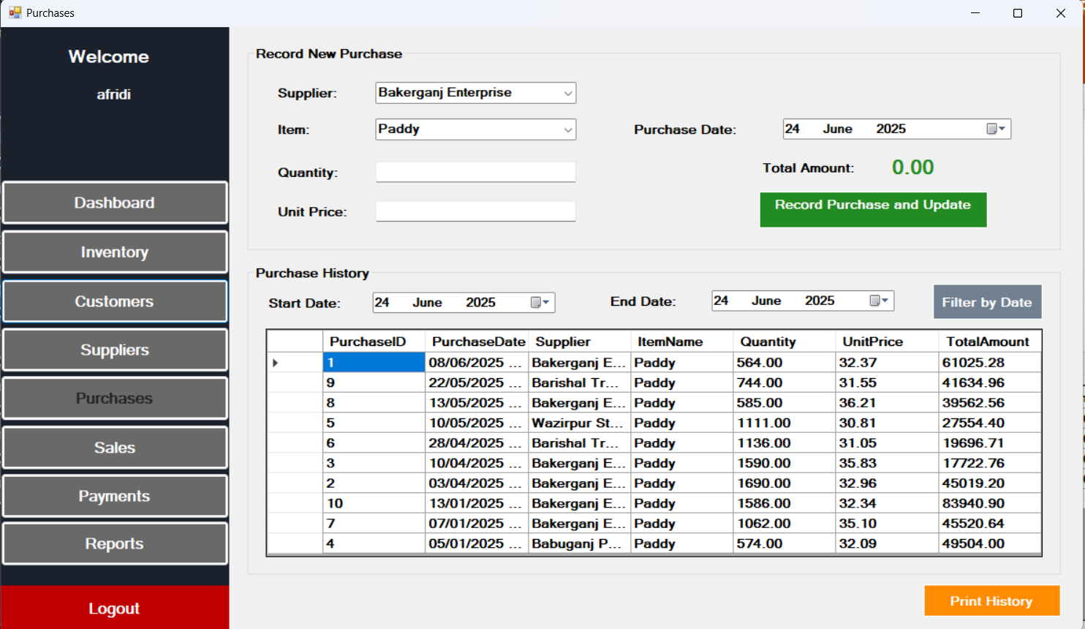
Sales Section
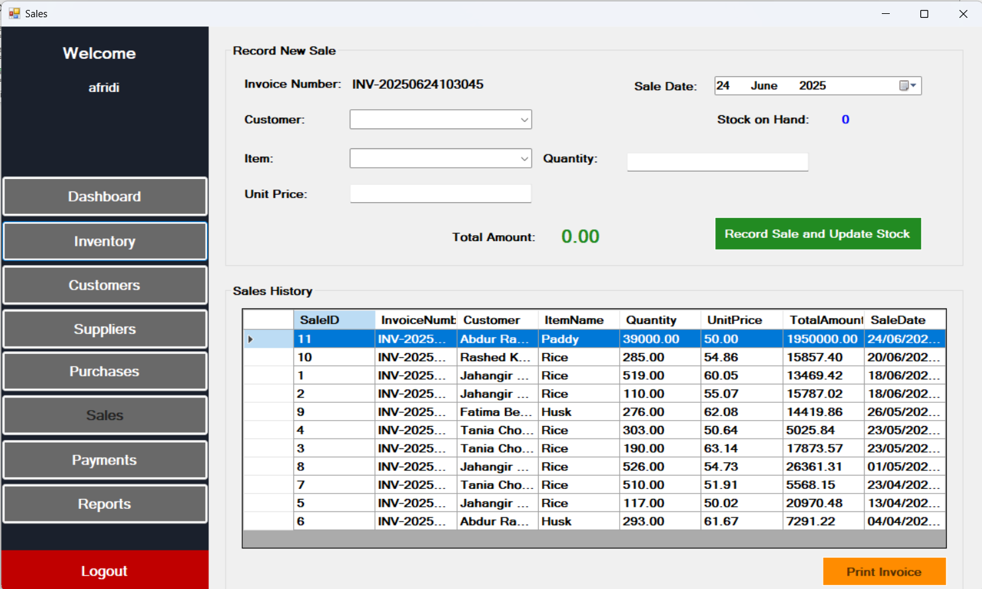
Payment Method
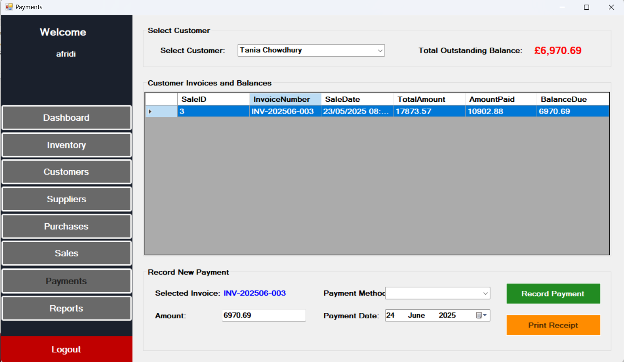
Generating Four Different Types of Reports
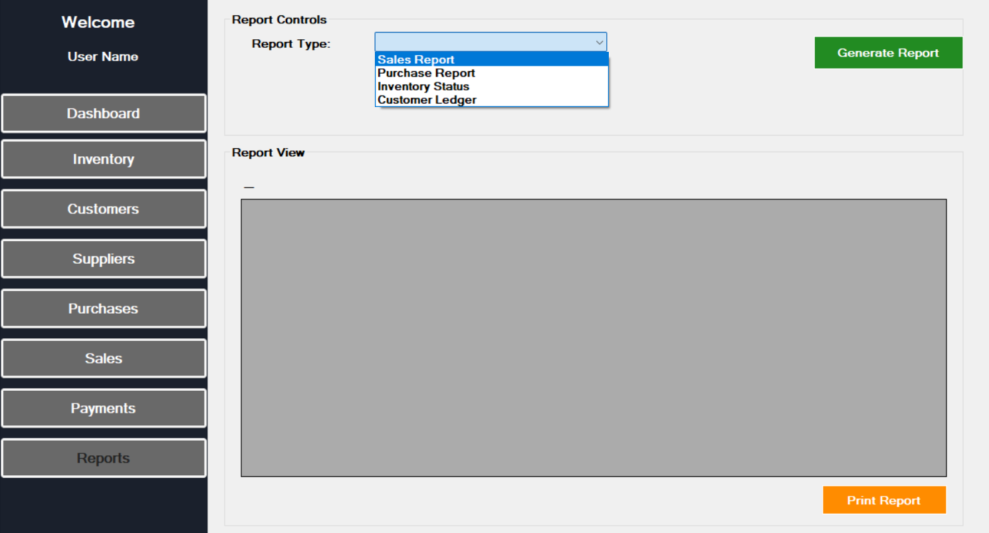

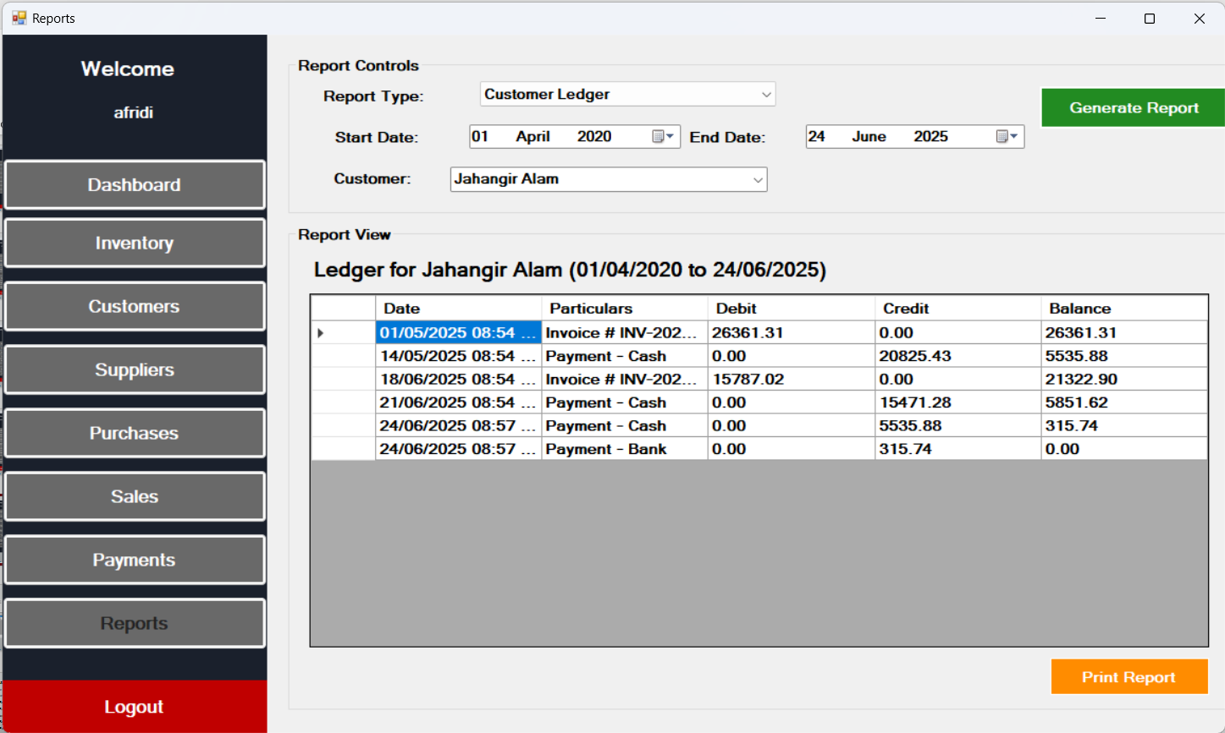

Printing Option for Generated reports:

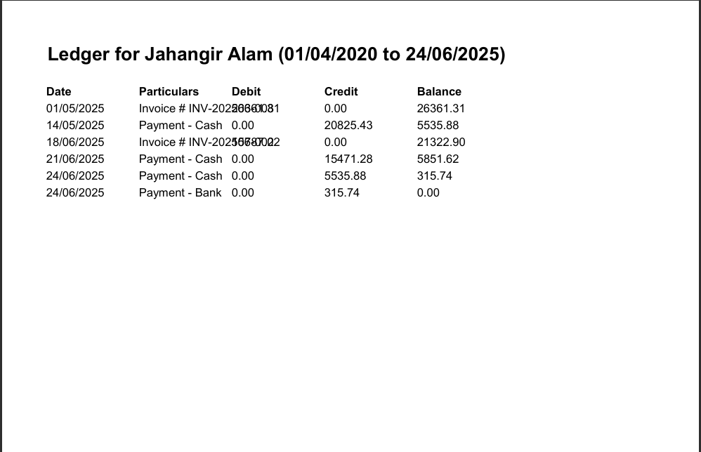

9. Outcome and Benefits
The system will bring the following benefits to Kohinoor Auto Rice Limited:
- Reduced Manual Errors
- Faster Decision Making
- Improved Operational Visibility
- Better Resource Planning
- Enhanced Traceability and Accountability

10. Conclusion
This project serves as a practical application of our learning in System Analysis. By identifying a real-world problem and developing a C#-based solution, we have not only enhanced our technical and analytical skills but also created a system that has the potential to positively impact the operations of Kohinoor Auto Rice Limited.

11. Attachment
